**WALL LANDING AIRCRAFT PERCHING**

# 1.1 DOCUMENT THE PROBLEM BY GAINING AGREEMENT

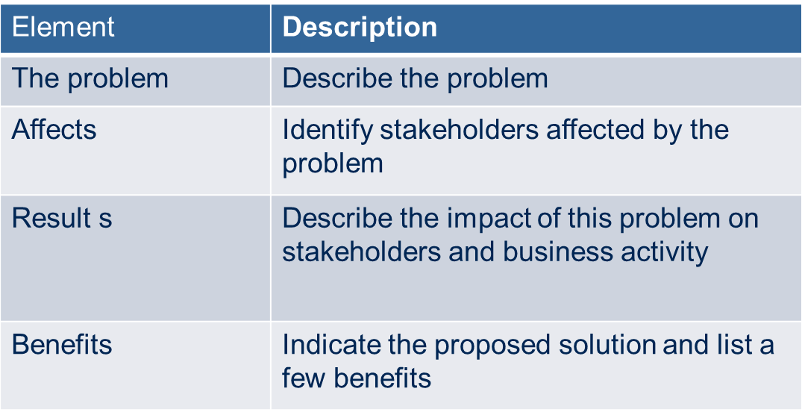

|  |  |
| --- | --- |
| Element | Description |
| The Problem | We have the continuous verbal threats from the foreign elements. |
| Affects | * All security agencies * inhabitants * government * Security personals |
| Results | Fear of foreign attacks and feeling of constant danger to the lives of inhabitants of the country. |
| Benefits | A constant defense for our country’s sovereignty. Advanced mechanized equipment for the safety of the country should be used for spying and instant reply to any foreign threats. |

|  |  |
| --- | --- |
| Element | Description |
| The Problem | Our country’s security agencies need to hire a lot of labor for the observatory purposes in the check post located all over the border of the country. |
| Affects | * Treasury dept. * Security agencies management department |
| Results | A lot of wages to be paid on monthly basis.  A strict check and balance to be maintained on all check posts. Which can be the caused of management problems |
| Benefits | To minimize this problem we should use the unmanned equipment of any kind (which is not directly controlled by man itself). Less labor/force will be required. Resources will be saved a lot which could be used in any other productive thing. More detailed information will be available to security agencies. |

|  |  |
| --- | --- |
| Element | Description |
| The Problem | If we need instant airstrike then the air force’s aircraft response to the average time of 5 to 10 minutes. |
| Affects | * Pilots * Air force |
| Results | Pilots have to be available for 24 hours.  We need constant airstrike available around the border. |
| Benefits | Wall landing aircrafts can response to any external threat within no time. Due to its small size and easy landing to any terrain. |

|  |  |
| --- | --- |
| Element | Description |
| The Problem | In our country, the energy resources are very scarce .so we have the available equipment, which uses a lots of fuel. |
| Affects | * Common people * Energy resources |
| Results | Energy resources will be used in huge amount  Less fuel would be available at the high priority places.  Decrease in supply results in increase prices of the fuel, conclusively resulted in increase in basic needs. |
| Benefits | We should have the equipment which uses the renewable resource of energy .in that way we can save the fuels for other purposes. |

|  |  |
| --- | --- |
| Element | Description |
| The Problem | The landing feasibility for the aircraft’s at the border area of our country is not at all good. |
| Affects | * Security agencies management department |
| Results | Difficulty for security agencies in controlling and maintaining defense system in remote areas of the country. |
| Benefits | We need such a technology which do not require large landing arrangements to privileged such limitations. |

|  |  |
| --- | --- |
| Element | Description |
| The Problem | If we have airstrike around the border it has the possibility that enemy could struck it down as according to the current statistics we have no low flying aircrafts available for spying. |
| Affects | * Diplomatic relations(submerged) * Security Agencies(info loss) * Treasury |
| Results | Fear of losing important confidential information of the country.  Even if a single aircraft is shot down or hijacked by the enemy results in a big loss to the treasury. |
| Benefits | We should have the small sized equipment capable of low flying so that it can deliver maximum information without getting noticed by the enemy. |

|  |  |
| --- | --- |
| Element | Description |
| The Problem | We need to use high resolution camera’s for high flying aircrafts that is very costly. We cannot use high resolution camera’s do maximum capability of spying enemy with high resolution camera’s with high flying aircraft until we use it on the low flying aircrafts. |
| Affects | * DIP programmers * Security Agencies (minute details) |
| Results | Blurring spying pictures  Minimum capability of spying  Cost could be very high for high resolution camras. |
| Benefits | Either we use very high resolution cameras or we fly the aircraft at low heights for gaining maximum capability of information. |

|  |  |
| --- | --- |
| Element | Description |
| The Problem | Statistically, we have UAV’s which can be controlled through particular systems designed specially and installed in the bases which do not gutter down the cost. |
| Affects | * Treasury * Security personals |
| Results | Highly expensive systems to monitor the UAV’s and its information.  Have to dedicate large area and employees at bases for monitoring and controlling the UAV’s.  Hardware overhead |
| Benefits | We have to introduce simple and easy to handle UAV’s and its monitoring applications which do not require extensive labors, hardware and space to be used and monitored, in turn saving lots of resources. |

|  |  |
| --- | --- |
| Element | Description |
| The Problem | If we use the manned air craft it would be risky because the person’s life is at stack. |
| Affects | * Pilots * Air force |
| Results | Danger of life loses to air force and pilots. |
| Benefits | We should introduce unmanned aircrafts to avoid all the possible life risks thus saving our pilots and resources for better use. |

# 1.2 UNDERSTAND THE ROOT CAUSE

|  |  |
| --- | --- |
| Element | Description |
| The Problem | We have strategical and economical reasons to have enmity with. We have land dispute problem with our neighbor (India) , long war history. |
| Affects | * People * Government * Security Organizations |
| Results | We have to use excessive military deployed near the border. We need to cut down the country’s budget to have mechanized and expensive military. The security personal’s life is at stake. |
| Benefits | Its worth fixing to have low cost military as compared to the fixing of the real problem, in which we need to have certain equipment which eradicate the risk to the lives of air security personals. Wall landing air-craft Perching is the solution which do not need runways or highly dense hardwares to control or cut down the country’s budget. |

# 1.3 IDENTIFYING THE STACKHOLDERS

|  |  |
| --- | --- |
| User | Other Stakeholders |
| Security Personel | Government |
| Pilots | Common people |
| Engineers(Maintenance) | Programmers (Digital Image Programming) |
|  | Treasury |
|  | Security Agencies management department |
|  | Diplomatic relations |

# 1.4 Vision Statement